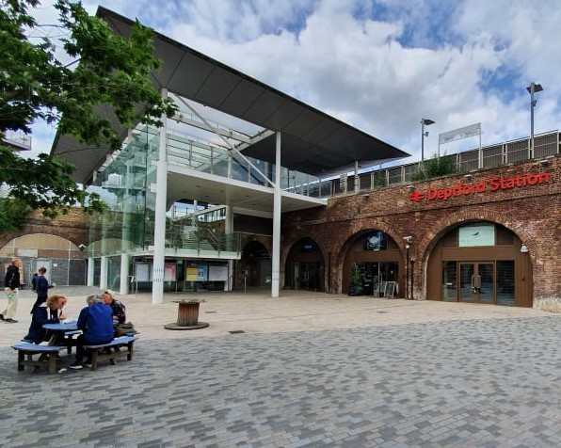
Deptford 2020
Deptford station opened on 8th February 1836, when the line from there to Spa Road became the first railway in London. On the 14th December 1836, the extension to London Bridge was opened, and the Lord Mayor of London, Rt. Hon. Sir Thomas Kelly, performed the official opening ceremony. It was described in The Times as follows: “Throughout the whole line the bells of the parish churches by which the railroad went rang merry peels. The house tops on both sides were teeming with spectators who loudly cheered as the engines passed.” At Deptford, the Board of Directors made a presentation to the Lord Mayor.
When the station opened, it stopped short of the High Street, as the bridge over it was dependent upon the solution to crossing the River Ravensbourne at Deptford Creek in order to reach Greenwich. When a drawbridge was decided upon, the bridge and further railway arches were constructed, and the track laid. The extension to Greenwich opened on 24th December 1838.
Passengers purchased tokens to ride on the railway, not paper tickets. In February 1838, turnstiles were installed at Deptford to stop early fare dodging by passengers travelling without a token.
From the beginning, Deptford was the site of workshops to maintain and service the engines and carriages. These workshops were at ground level, using the arches underneath the railway. To get between ground level and the viaduct an inclined plane was built.

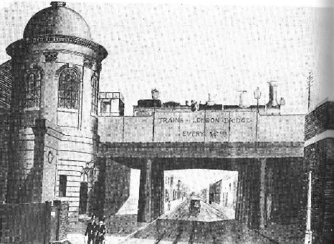
In 1842, the station was rebuilt, when the viaducts and platforms were widened, and an engine shed, carriage shed and coke house built. This station was built by Baker & Sons, the same company that had built Greenwich station. A turntable was installed at the point where the inclined plane joined the viaduct (today that is the waste ground at the London end of the up platform).
Deptford 1842

There is a description of the station in 1855 (source unknown): “Deptford Railway Station……..is a small erection, containing a checktaker’s and waiting rooms, with the usual accessories. …..It’s distinguishing feature, from whatever side it is approached, is a circular building, containing the staircase for enabling the down passengers to reach the street……..a dingy, stuccoed, uninteresting building.”
The station was partially rebuilt again in 1904, when the platforms were lengthened and widened. At this time, the engine and carriage sheds were closed, with the work transferred to Slade Green. The circular tower referred to above was also demolished. The station was closed on 15th March 1915.

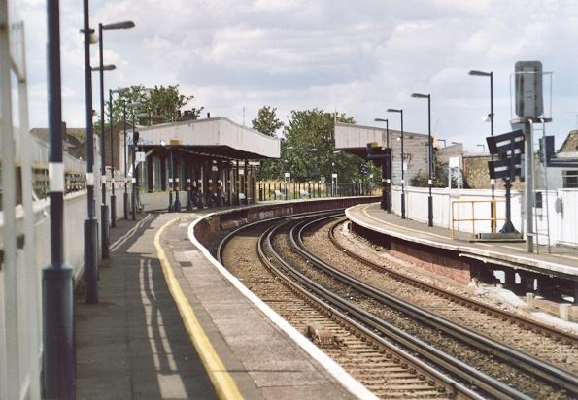
Deptford station re-opened on 19th July 1926, when the line was electrified. It had typical South Eastern Railway platform canopies, which were demolished as part of the extensive rebuild in 2010.
The old station canopies
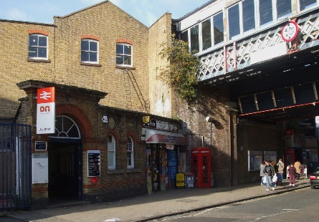
Today’s station opened in April 2012. Deptford then became a single station, with the arches being re-furbished and lifts installed to access both platforms. Until then, the down platform had been accessed by a separate staircase direct from the High Street. That staircase is now closed but still exists as a fire exit.
Station entrance before the rebuild
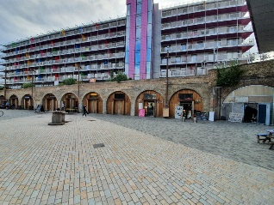

The inclined plane built in 1838 to get trains and carriages to the workshops still exists and during the station’s rebuild it was refurbished and brought into use as an entrance to the up platform, with businesses in the arches.

Ramp after restoration

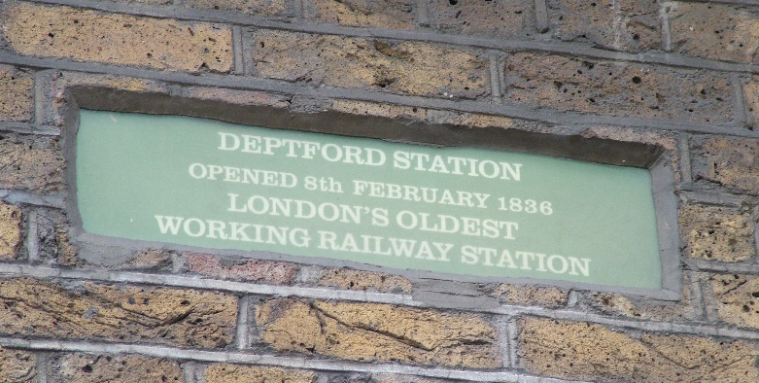
Unfortunately, the plaques shown below disappeared during the refurbishment.
