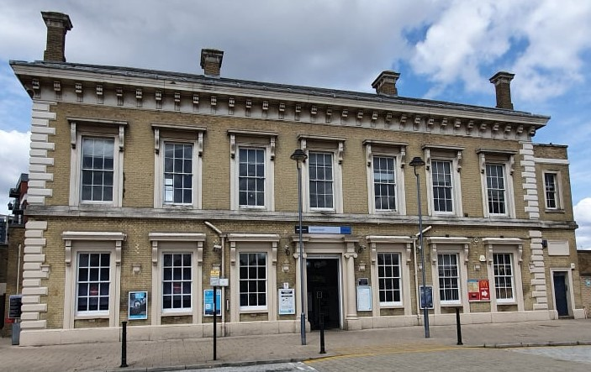
Greenwich 2020
Greenwich station opened on 24th December 1838, when the line was extended from Deptford. Prior to that, in 1836, a temporary booking office had been established at Rose Cottage, which was in a lane beside the North Pole Tavern. Passengers would collect their tickets, go through a back door to a footpath across a field and a temporary footbridge over the River Ravensbourne to join the railway path to Deptford station.
The original 1838 station was a temporary building at Church Row, with wooden steps leading up to the viaduct. A map from 1836 shows Church Row to be where the western end of Straightsmouth now is.
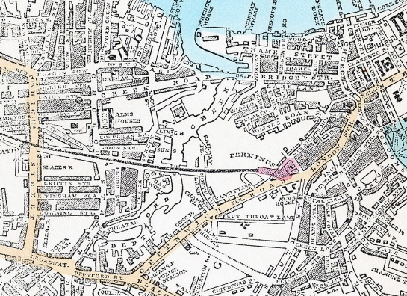
Greenwich map 1851
Plans for a permanent station were produced in 1839, designed by George Smith, and the contract to build it was awarded to Baker & Sons. The opening of the station was delayed when a fire caused some damage during its construction, and it eventually opened on 12th April 1840. The new station faced on to London Street and was designed and built as a terminus.

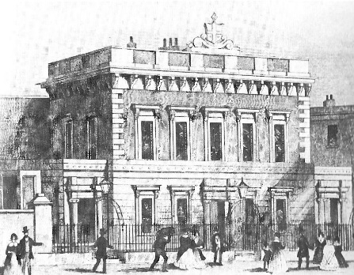
The Railway Times described the station as follows: “The trains run under a shed of 60ft. (18.3m) span, having 12ft. (3.7m) of pavement on each side, forming a promenade 300ft. (91.4m) in length, eleven large windows looking into the London road and the same number giving a view towards the Thames. A handsomely finished stone staircase, 10ft (3m) wide, leads to the waiting rooms, and down about twenty stone steps into a colonnade, through which the passengers pass into the London road, Greenwich.”
Greenwich 1840

Until 1843, trains arriving at Greenwich were met by omnibuses for Woolwich, Blackheath and Lewisham. These were operated by Thomas Wheatley, who stabled his horses in the railway arches. This arrangement came to an end when he set up a bus service to London, rivalling the train service, and the train Company did not renew his contract.
When the rail connection to Maze Hill was built, the station had to be changed from a terminus to allow through runnning. The station was dismantled and rebuilt using the same Portland Stone. It was close to the same site, but a bit further back from Greenwich, where it stands today. The railway arches from Norman Road to the station were demolished, so the railway could reach street level before descending into the tunnel underneath Greenwich Park. On 1st February 1878 the first train left the new Greenwich station for Maze Hill. The station is substantially the same today, and was Grade II listed in 1973.
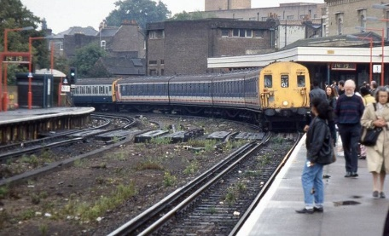
1992
The layout of the tracks was altered, and the up platform changed, to allow for the construction of the DLR, which opened in 1999. The original canopy over the up platform remains today.

