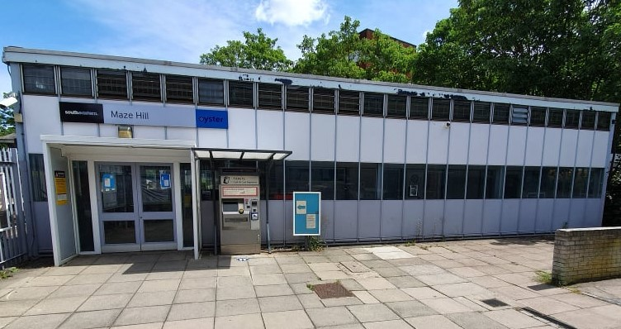
Maze Hill station 2020
Maze Hill station opened on 1st January 1873. The line was not connected to Greenwich at that time, but was a spur from the North Kent line at Charlton. It was worked by a single train and the 1874 Bradshaw’s timetable shows it making 14 round trips a day, from Maze Hill to Woolwich Arsenal or Maze Hill to Charlton.
The work to complete the connection to Greenwich was completed in July 1876, following years of objections from the Admiralty to tunnelling under the Royal Park. Even after those objections were overcome, the opening was further delayed by a protracted dispute with the Board of Trade over the track layout and the lack of a turntable at Charlton. The through line eventually opened on 1st February 1878.

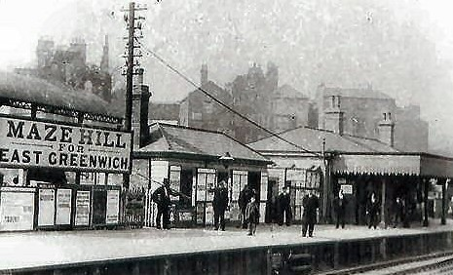
The 1879 Bradshaw’s timetable shows a 20-minute service from Charing Cross to Woolwich Arsenal at peak times, but off-peak some trains terminated in the bay platform at Maze Hill, on the down side. The edge of that bay platform can still be seen today, although it has not been used as such for many years.
Maze Hill up platform, date unknown

Maze Hill had a large carriage storage facility. Sidings were installed and used to store carriages for the North Kent line. Where the allotments and Seren Park are today, there were six eastward-facing tracks, and a further five westward-facing tracks on the north side. These extensive carriage sidings were not provided with third rail when the line was electrified in 1926, but remained in place and hosted locomotive-hauled rolling stock. Their use gradually declined and by the time of the completion of the Kent Coast Electrification project in 1962 all the tracks had gone out of use.
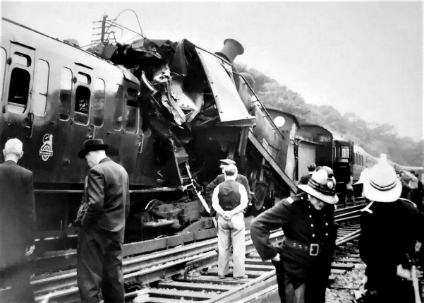
There was a bad accident, with 45 people injured, on 4th July 1958. The accident was caused when an electric passenger train from Gravesend passed a red signal and collided head-on with an empty nine carriage steam train being shunted from the sidings. The force of the impact drove the empty train back 11 yards and lifted the engine over the front carriage of the passenger train.
The original station building was destroyed by a fire in 1971 and the main station building seen today was opened on 14th July 1972. The single-storey rectangular all-glazed structure was trialled by British Rail as a “modern image” suburban station and it was opened in a formal ceremony by the Mayor of Greenwich. Similar structures were built at Dartford and Chelsfield around the same time. Regrettably, the building has not stood the test of time in the same way that the original buildings at Greenwich and Westcombe Park have done.

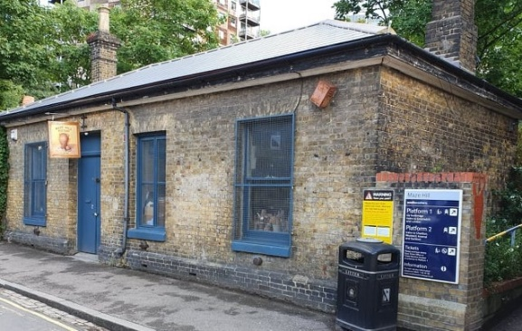
Maze Hill Pottery
On the down side, an original station building does still exist. It is no longer used by the railway, although there remains a station entrance next to it, but is in use as a Pottery.

