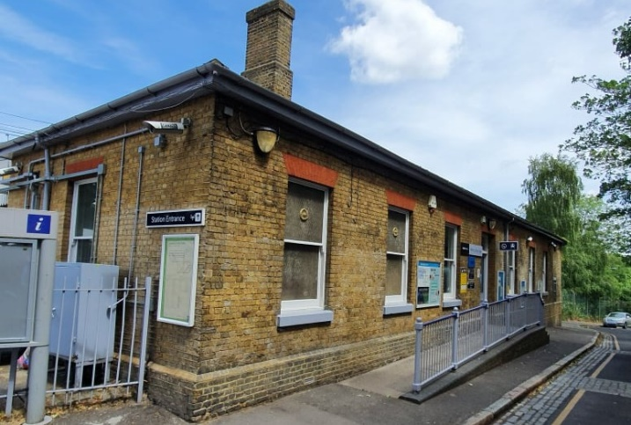
Westcombe Park 2020
Westcombe Park was the last station to open on the line. It was opened as Coombe Farm Lane on 1st May 1879. Maps from the time show that the Coombe Farm was still in existence in 1886, but by 1888 the farm had gone, and the station’s name had been changed to Westcombe Park. The precise date of the name change is not known, but probably coincides with the development around Westcombe Hill on land previously occupied by the farm. It seems reasonable to assume this was part of a Victorian housing development on the site of the old farm.
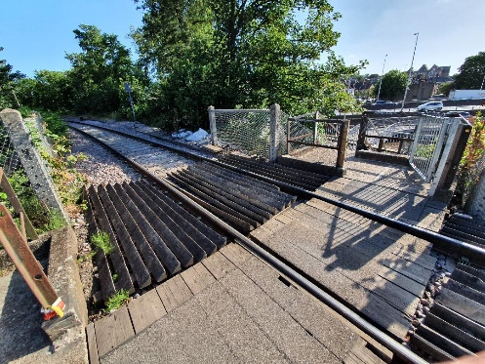
When the freight line to Angerstein Wharf was built in 1851, it had cut Coombe Farm into two, and so a foot crossing over the line was provided for farm workers. This foot crossing is still in use today and survived an attempt to close it in 2018. The footpath remains in the form of the footbridge over the A102 and gives access to Westcombe Park station from east of the main road.
Angerstein foot crossing 2020

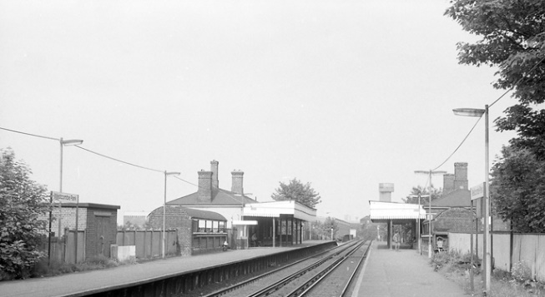
There were originally near identical station buildings on both sides of the tracks. The canopy and building on the north side (on the left in the picture) were demolished in the early 1980’s. There is a subway between the platforms with idiosyncratic South Eastern Railway roof-protected entrances. These, and the south side building and canopy, remain today in their original design, apart from the loss of one chimney.
Westcombe Park station 1980

There seems to have been little further to note about Westcombe Park, which continues to fulfil its original function as an intermediate passenger stop on the line between Greenwich and Charlton.

